Smart Tachograph V2 and EU Mobility Package - Order Form 2023
(Initial orders placed on DTCO 4.1 in July/August are subject to additional quantity rate discounts – see below)
Part Number | Description | Workshop Price | Quantity Required

Total
Customer Details
Please complete the details below in full for order Processing
Purchase Order Number
Account Number
Full Delivery Address
Contact Name
Contact Telephone Number
Contact Email

Continental Automotive Trading UK Ltd 36 Gravelly Industrial Park Birmingham
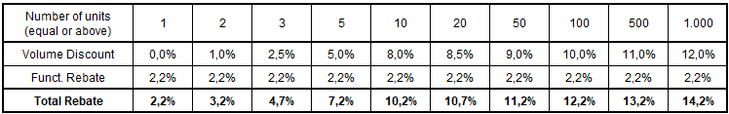
B24 8TA
Tel: 0121 725 1234
Email: uk@vdo.com
www.vdo.co.uk | www.vdo-fleet.co.uk
VDO - A Brand of the Continental Corporation

